**Eclipse Download and Install Instructions - Windows**

(If you want to download the Java Development Kit (JDK), which is necessary in order to run eclipse, you can skip to the last page)

**ECLIPSE DOWNLOAD:**

1. Go to <http://www.eclipse.org/getting_started/>
2. Click on the orange “Download Eclipse IDE”  
   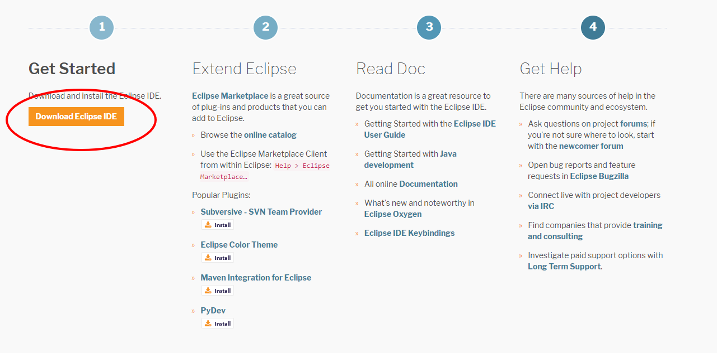
3. Click on the orange “Download 64 bit” orange button. If you are looking to download the 32 bit package, click on “Download Packages” under the orange button and it’ll give you an option to download the 32 bit eclipse package. (Java IDE for Java Developers)  
   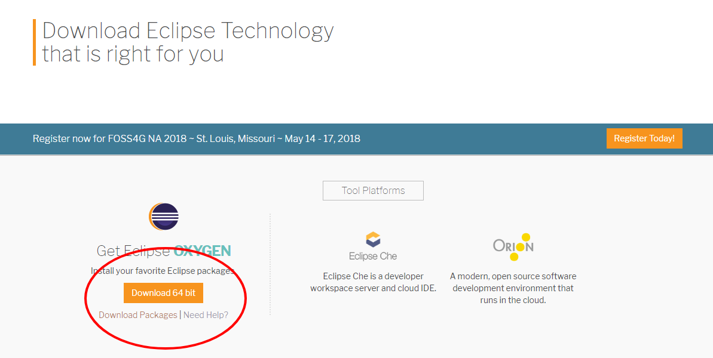
4. It’ll give you an orange “Download” option on more time. Click on that.  
   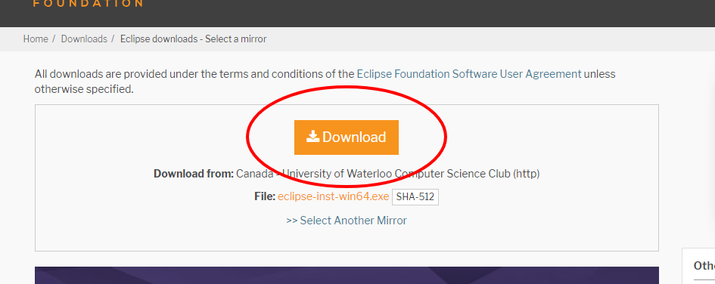
5. Now you should see in your downloads “eclipse-inst-win64.exe” If you don’t see it in the downloads bar at the bottom, go to downloads and find it. Then click on it and open it.  
   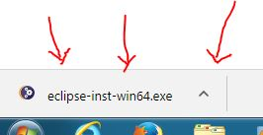
6. Once open, it should show you this. Click on Eclipse IDE for Java Developers.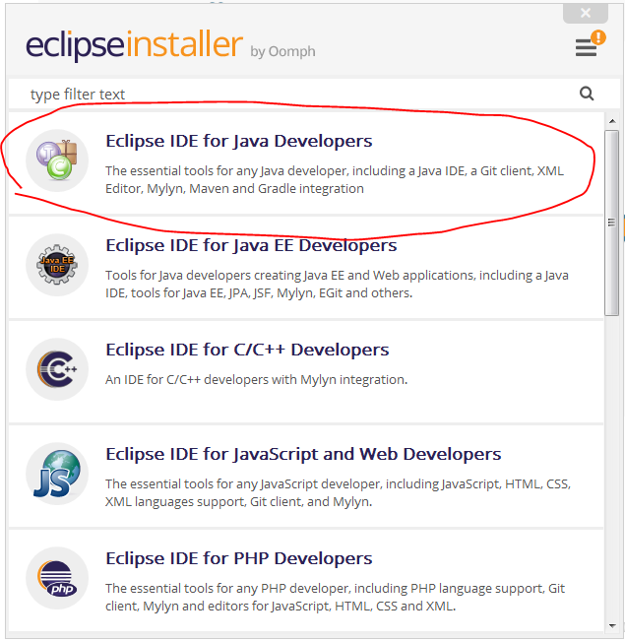
7. After choosing which folder to install Eclipse in, make sure the two checkboxes are selected and proceed to click on the orange “INSTALL” button.  
   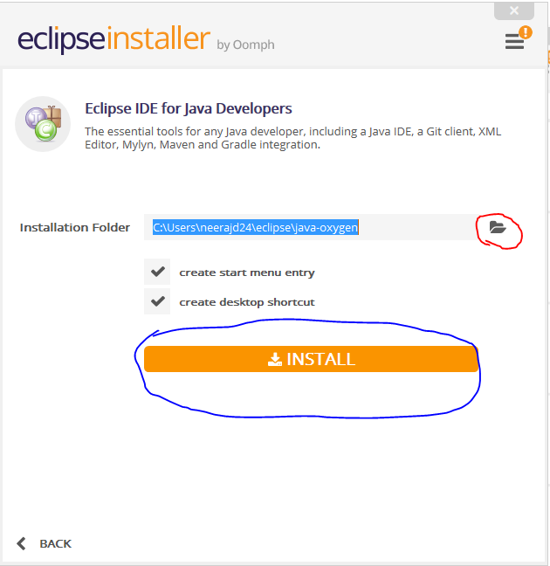
8. Read through the user agreement and click on “Accept Now” to complete the process.  
   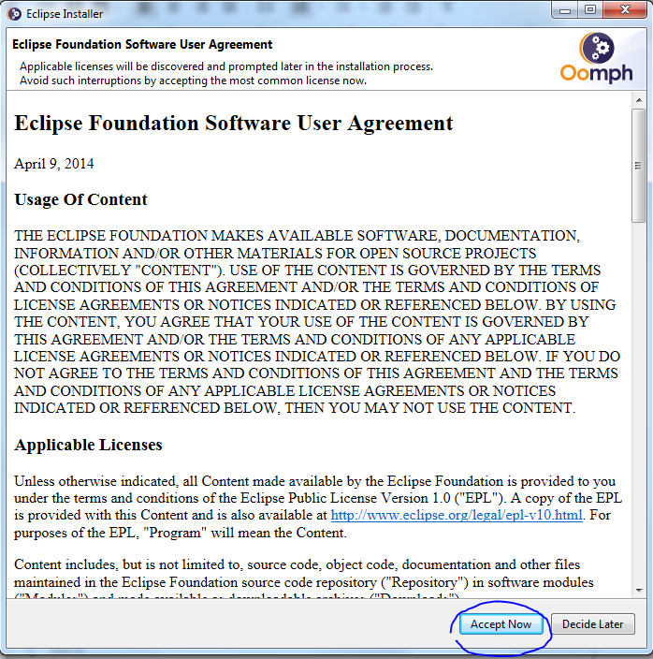
9. It may proceed to ask for more agreements. Continue reading through and accepting until you get to this. Click on “Launch”.  
   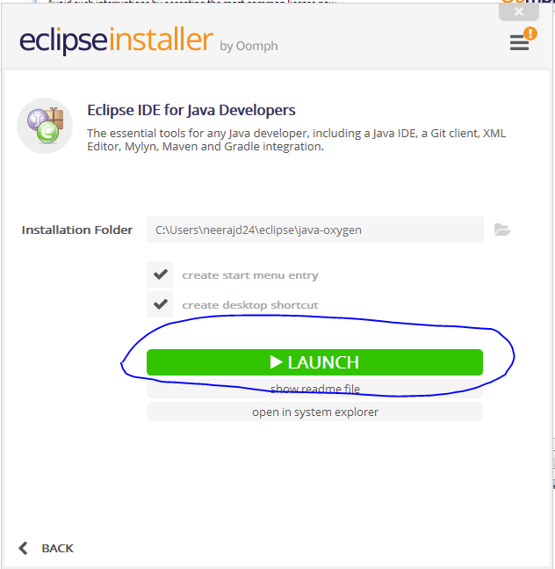
10. Select a folder path and create a workspace by saying “Launch” again. You are now done installing Eclipse.
11. Remember that you need to have a JDK downloaded and installed in order for Eclipse to run. See the next page to install the JDK.
12. To create your Java project, navigate to File → New → Java Project  
    In that Project, you can add Java Classes where you can begin coding.

JAVA DEVELOPMENT KIT - JDK  
(Eclipse uses JDK package as its java platform)

Download:

1. Go to <http://www.oracle.com/technetwork/java/javase/downloads/index.html>
2. Click on download button for “Java Platform (JDK) 10” to download the platform  
   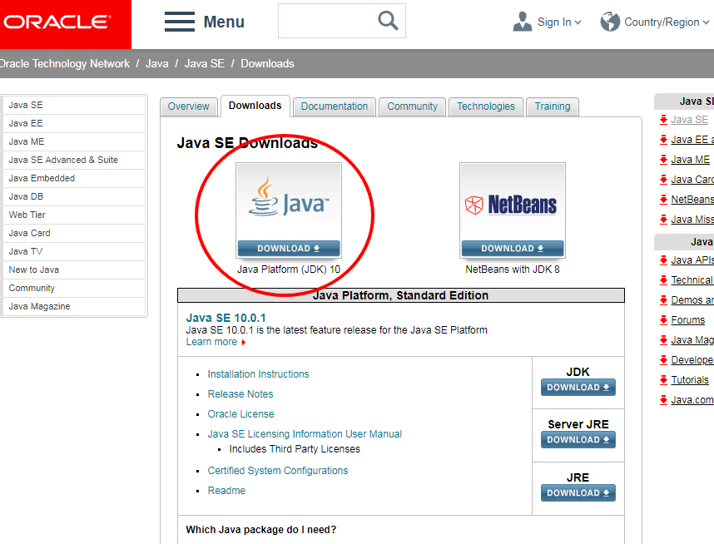
3. For windows, click on the windows version for the kit. Check “accept license agreement” before downloading. The default is checked as “Decline” so it won’t let you proceed.  
   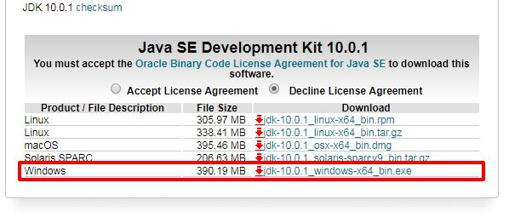
4. Open the file from the downloads and then you will be able to use Eclipse on the JDK platform. You are all set.